Lab 10B: Repeated Measures and Mixed Designs.
In this lab, we will focus on completing ANOVA tables for more complex designs and interpreting the statistical output. The sums of squared errors will already be given to us, so the goal is to understand what partitioning the variance means at a conceptual level (e.g., which factors explain variation in the outcome between-subjects and which factors explain variation in the outcome within-subjects).
For this lab, we will use a hypothetical experiment in which older adults (n=20; >65 y; shown as the red dots below) and younger adults (n=20; <30 y; shown as blue dots below) walked in a virtual environment for 4 different trials and under 3 different conditions (A, B, and C). For each trial and condition, we have drawn a boxplot to show the median and the interquartile range. When we consider the full model, we have a 2 (Age Group) x 4 (Trial) x 3 (Condition) mixed-factorial design.
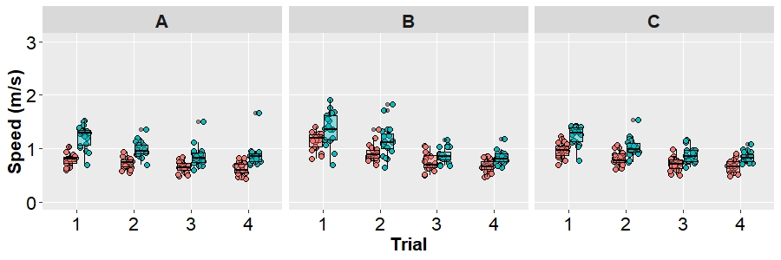
This is a “mixed” design because Age Group varies between-subjects (you can only be either an older adult or a younger adult), whereas Trial and Condition vary within-subjects (all subjects completed all four trials in all three conditions).
Below we will build up this analysis in a series of steps: focusing on only one within-subject variable; focusing on both within-subject variables; and considering the fully factorial design. As we go, pay careful attention to the structure of the ANOVA table and how that maps onto different levels of variation in the outcome (speed in m/s). There is some amount of TOTAL variance that needs to be explained, our variables will REDUCE (or EXPLAIN) some of that variacne, but even then there will be ERRORS (or RESIDUALS) that remain to be explained at each level.

Question 1. One-Way RM ANOVA for the effect of Trial:
To focus on only the effect of trial, we will average across conditions. We will also ignore the distinction between older and younger adults (pooling those data together into one big sample). Note that this does not map onto the experimental design, we are just doing it for educational purposes to focus on the within-subject effect of trial. Averaging over conditions and ignoring age group means that we 4 observations per person: one for each trial as shown below. Notice that speeds were generally faster on the first trial and tended to decrease over time.
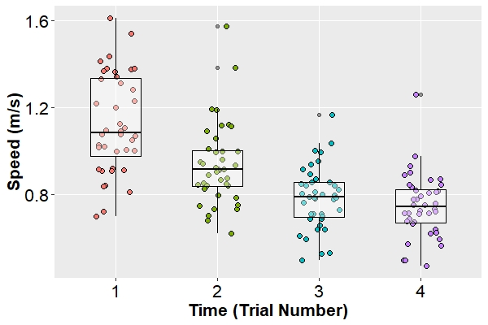
Using a one-way RM ANOVA to analyze these data these data in R:
mod1<- aov(speed ~ time + Error(subID/(time)), data=data_TIME)
summary(mod1)
… we get the following ANOVA table. Note this table is incomplete. Fill in the missing cells with the correct values below.
Source | SS | df | MS | F | p
Between Subjects
Total (Between) | 3.668 | 39 | ANS
Within Subjects
Trial | 3.539 | 3 | ANS | ANS | <0.001
Error (Within) | 1.303 | 117 | ANS
Total (Within) | 4.842 | 120
Total | ANS

The omnibus effect of Trial is statistically significant.
- Given this statistically significant effect, how many post-hoc comparisons would we need to run to compare every trial to other trial?
  - 6

The means for each condition are given in the table below. The cells to the right then show the p-values we get when comparing each condition to every other condition.
Trial | Mean | versus 1 | versus 2 | versus 3
1 | 1.126
2 | 0.936 | <0.0001
3 | 0.785 | <0.0001 | <0.001
4 | 0.748 | <0.0001 | <0.001 | 0.0012

- Given these statistically significant differences, how might you explain this pattern of results? Be sure to reference the omnibus F-test and the post-hoc comparisons in your answer.
  - ANS

- Given we have run multiple post-hoc tests, let’s assume we want to be conservative and correct for multiple comparisons. Using a Bonferroni correction ($α_{adj}=α/c$) we can adjust the alpha based on the number of comparisons to keep the overall alpha level at 5%. (Note that c = the number of comparisons in the Bonferroni correction.)
  - What is your adjusted alpha level following the Bonferroni correction?
    - ANS

  - We have just analyzed our data two ways (with and out a correction). In general this is a bad habit because you should have an analysis plan before you see any results and stick to it. However, this is useful to do as an educational exercise.
Can you explain a research question for which you might want to be less conservative (and not correct) and contrast that against a research question where you might want to be more conservative (and make a correction)?
    - ANS

Question 2. Two-Way RM ANOVA for the effects of Trial and Condition:
Next, we will expand our model to account for both of the within-subject factors: Trial and Condition. As shown in the figure below, all subjects completed all four trials in each of the three conditions. As a result, this means that we now have 12 data points per person. Note that although speed generally decreased across conditions, the rate of change may depend on the condition.
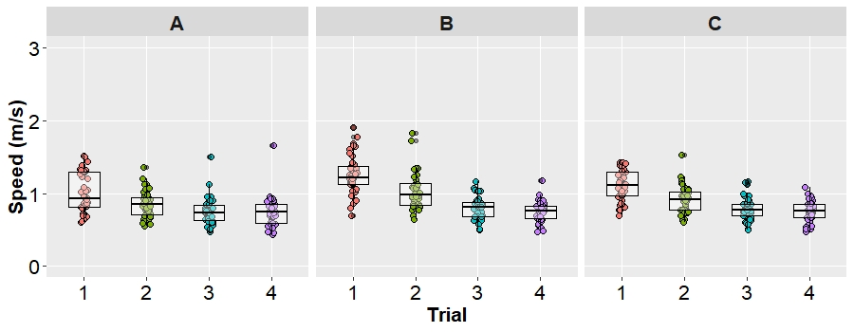
Using a two-way RM ANOVA to analyze these data these data in R:
mod2<- aov(speed ~ condition*time + Error(subID/(condition*time)), data=DATA)
summary(mod2)
… we get the following ANOVA table. Note this table is incomplete. Fill in the missing cells with the correct values below.
Source | SS | df | MS | F | p
Between Subjects
Total (Between) | 11.005 | 39 | 0.2822
Within Subjects
Condition | 1.128 | ANS | ANS | ANS | <0.001
Error (Within:Condition) | 1.798 | 78 | ANS
Total (Within:Condition) | ANS | 80
Trial | 10.618 | ANS | ANS | ANS | <0.001
Error (Within:Trial) | 3.909 | 117 | ANS
Total (Within:Trial) | ANS | 120
Condition x Trial | 0.785 | 6 | ANS | ANS | <0.001
Error (Within:C x T) | 2.263 | 234 | ANS
Total (Within:C x T) | ANS | 240
Total | ANS

In the table below, the means for each combination of Trial and Condition are provided.
 | Condition
Trial | A | B | C
1 | 1.01 | 1.26 | 1.11
2 | 0.86 | 1.03 | 0.92
3 | 0.76 | 0.80 | 0.79
4 | 0.75 | 0.75 | 0.75

Using these means, provide an interpretation of the main-effects of Trial and Condition and an interpretation of the Trial x Condition interaction. Note that p-values for specific post-hoc tests are not provide, but you can still accurately describe the patterns that you observe (e.g., which condition was fastest on average? In which condition did time change the most?).
- Main-Effect of Condition: ANS

- Main-Effect of Trial: ANS

- Condition x Trial Interaction: ANS

Question 3. Mixed Factorial Model:
Next, we will expand our model to account for both of the within-subject factors (Trial and Condition) and the between-subjects factor of Age Group. As shown in the figure below, all subjects completed all four trials in each of the three conditions, but we have the added wrinkle of needing to account for the fact that some of our participants are older adults (n = 20; red dots) and some of our participants are younger adults (n = 20; blue dots). As before, we have 12 observations per person in these data.
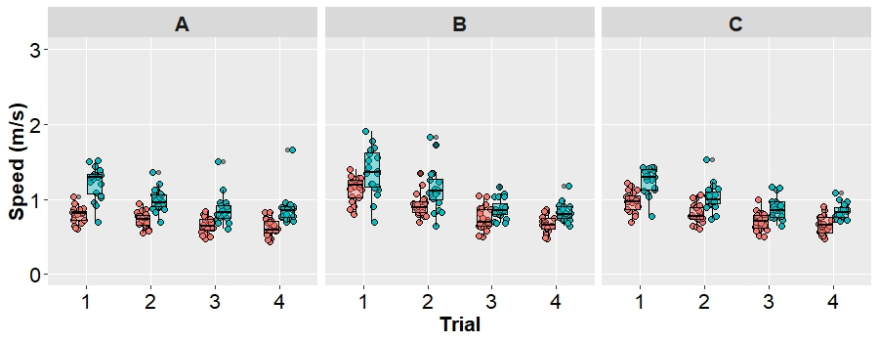
Using a mixed-factorial ANOVA to analyze these data these data in R:
mod3<- aov(speed ~ age_group*condition*time + Error(subID/(condition*time)), data=DATA)
summary(mod3)
… we get the following ANOVA table. Note this table is incomplete. Fill in the missing cells with the correct values below.
Source | SS | df | MS | F | p
Between Subjects
Age Group | 6.095 | 1 | 6.095 | 47.18 | <0.001
Error (Between) | 4.910 | 38 | 0.129
Total (Between) | ANS | 39
Within Subjects
Condition | 1.128 | 2 | 0.5639 | ANS | <0.001
Condition x Age Group | 0.227 | 2 | 0.1133 | ANS | 0.006
Error (Within:Condition) | 1.571 | 76 | 0.0207
Total (Within:Condition) | ANS | 80
Trial | 10.618 | 3 | 3.539 | ANS | <0.001
Trial x Age Group | 0.366 | 3 | 0.122 | ANS | 0.011
Error (Within:Trial) | 3.543 | 114 | 0.031
Total (Within:Trial) | ANS | 120
Condition x Trial | 0.785 | 6 | 0.13084 | ANS | <0.001
Condition x Time x Age Group | 0.088 | 6 | 0.01467 | ANS | 0.166
Error (Within:C x T) | 2.175 | 228 | 0.00954
Total (Within:C x T) | ANS | 240
Total | ANS

This table is largely filled in, but notice the complexity of the design. We now have 4 different levels at which variance is being explained in our experiment (Between subjects and Within-Subjects at levels of Condition, Trial, and the Condition x Trial interaction). Rather than focusing on calculations, we want to focus on some “big picture” conceptual questions.
- Notice that the sum of squared errors TOTAL at each level of the experiment still match what we had in the two-way repeated measures ANOVA with only the effects of Trial and Condition. Explain why these total errors still match even though we have added Age Group and its interactions to the model:
  - ANS

- Take a look at the degrees of freedom for the sum of squared errors REDUCED at each level of the model. Concisely explain df = 3 for the effect of trial in the simplest language possible (e.g., try running your answer by a fellow student to see if it makes sense):
  - ANS

- Take a look at the degrees of freedom for the sum of squared errors of the ERROR term at each level of the model. Do your best to concisely explain why the degrees of freedom are smallest at the between subjects level (38), larger for Condition (76), larger for trial (114), and largest for the Condition x Trial interaction (228):
  - ANS

